**Creating the Application**

**1. Fire up your terminal and create a new folder for the application.**

$ mkdir node-easy-notes-app

**2. Initialize the application with a package.json file**

Go to the root folder of your application and type npm init to initialize your app with a package.json file.

$ cd node-easy-notes-app

$ npm init

name: (node-easy-notes-app)

version: (1.0.0)

description: Never miss a thing in Life. Take notes quickly. Organize and keep track of all your notes.

entry point: (index.js) server.js

test command:

git repository:

keywords: Express RestAPI MongoDB Mongoose Notes

author: callicoder

license: (ISC) MIT

About to write to /Users/rajeevkumarsingh/node-easy-notes-app/package.json:

{

"name": "node-easy-notes-app",

"version": "1.0.0",

"description": "Never miss a thing in Life. Take notes quickly. Organize and keep track of all your notes.",

"main": "server.js",

"scripts": {

"test": "echo \"Error: no test specified\" && exit 1"

},

"keywords": [

"Express",

"RestAPI",

"MongoDB",

"Mongoose",

"Notes"

],

"author": "callicoder",

"license": "MIT"

}

Is this ok? (yes) yes

Note that I’ve specified a file named server.js as the entry point of our application. We’ll create server.js file in the next section.

**3. Install dependencies**

We will need express, mongoose and body-parser modules in our application. Let’s install them by typing the following command -

$ npm install express body-parser mongoose --save

I’ve used --save option to save all the dependencies in the package.json file. The final package.json file looks like this -

{

"name": "node-easy-notes-app",

"version": "1.0.0",

"description": "Never miss a thing in Life. Take notes quickly. Organize and keep track of all your notes.",

"main": "server.js",

"scripts": {

"test": "echo \"Error: no test specified\" && exit 1"

},

"keywords": [

"Express",

"RestAPI",

"MongoDB",

"Mongoose",

"Notes"

],

"author": "callicoder",

"license": "MIT",

"dependencies": {

"body-parser": "^1.18.3",

"express": "^4.16.3",

"mongoose": "^5.2.8"

}

}

Our application folder now has a package.json file and a node\_modules folder -

node-easy-notes-app

└── node\_modules/

└── package.json

**Setting up the web server**

Let’s now create the main entry point of our application. Create a new file named server.js in the root folder of the application with the following contents -

const express = require('express');

const bodyParser = require('body-parser');

// create express app

const app = express();

// parse requests of content-type - application/x-www-form-urlencoded

app.use(bodyParser.urlencoded({ extended: true }))

// parse requests of content-type - application/json

app.use(bodyParser.json())

// define a simple route

app.get('/', (req, res) => {

res.json({"message": "Welcome to EasyNotes application. Take notes quickly. Organize and keep track of all your notes."});

});

// listen for requests

app.listen(3000, () => {

console.log("Server is listening on port 3000");

});

**First**, We import express and body-parser modules. [Express](https://www.npmjs.com/package/express), as you know, is a web framework that we’ll be using for building the REST APIs, and [body-parser](https://www.npmjs.com/package/body-parser) is a module that parses the request (of various content types) and creates a req.body object that we can access in our routes.

**Then**, We create an express app, and add two body-parser middlewares using express’s app.use() method. A [middleware](http://expressjs.com/en/guide/writing-middleware.html) is a function that has access to the request and response objects. It can execute any code, transform the request object, or return a response.

**Then,** We define a simple GET route which returns a welcome message to the clients.

**Finally,** We listen on port 3000 for incoming connections.

All right! Let’s now run the server and go to [http://localhost:3000](http://localhost:3000/) to access the route we just defined.

$ node server.js

Server is listening on port 3000

[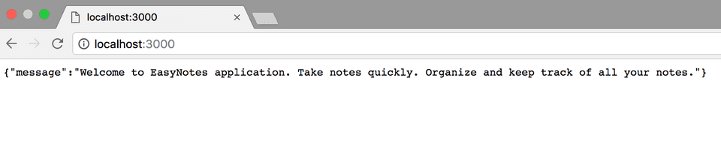](https://www.callicoder.com/static/9d7cd5d4bf90b7b5d46c73ab0db18c38/d3deb/node-express-mongoose-rest-api-tutorial.png)

**Configuring and Connecting to the database**

I like to keep all the configurations for the app in a separate folder. Let’s create a new folder config in the root folder of our application for keeping all the configurations -

$ mkdir config

$ cd config

Now, Create a new file database.config.js inside config folder with the following contents -

module.exports = {

url: 'mongodb://localhost:27017/easy-notes'

}

We’ll now import the above database configuration in server.js and connect to the database using mongoose.

Add the following code to the server.js file after app.use(bodyParser.json()) line -

// Configuring the database

const dbConfig = require('./config/database.config.js');

const mongoose = require('mongoose');

mongoose.Promise = global.Promise;

// Connecting to the database

mongoose.connect(dbConfig.url, {

useNewUrlParser: true

}).then(() => {

console.log("Successfully connected to the database");

}).catch(err => {

console.log('Could not connect to the database. Exiting now...', err);

process.exit();

});

Please run the server and make sure that you’re able to connect to the database -

$ node server.js

Server is listening on port 3000

Successfully connected to the database

**Defining the Note model in Mongoose**

Next, We will define the Note model. Create a new folder called app inside the root folder of the application, then create another folder called models inside the app folder -

$ mkdir -p app/models

$ cd app/models

Now, create a file called note.model.js inside app/models folder with the following contents -

const mongoose = require('mongoose');

const NoteSchema = mongoose.Schema({

title: String,

content: String

}, {

timestamps: true

});

module.exports = mongoose.model('Note', NoteSchema);

The Note model is very simple. It contains a title and a content field. I have also added a [timestamps](http://mongoosejs.com/docs/guide.html#timestamps) option to the schema.

Mongoose uses this option to automatically add two new fields - createdAt and updatedAt to the schema.

**Defining Routes using Express**

Next up is the routes for the Notes APIs. Create a new folder called routes inside the app folder.

$ mkdir app/routes

$ cd app/routes

Now, create a new file called note.routes.js inside app/routes folder with the following contents -

module.exports = (app) => {

const notes = require('../controllers/note.controller.js');

// Create a new Note

app.post('/notes', notes.create);

// Retrieve all Notes

app.get('/notes', notes.findAll);

// Retrieve a single Note with noteId

app.get('/notes/:noteId', notes.findOne);

// Update a Note with noteId

app.put('/notes/:noteId', notes.update);

// Delete a Note with noteId

app.delete('/notes/:noteId', notes.delete);

}

Note that We have added a require statement for note.controller.js file. We’ll define the controller file in the next section. The controller will contain methods for handling all the CRUD operations.

Before defining the controller, let’s first include the routes in server.js. Add the following require statement before app.listen() line inside server.js file.

// ........

// Require Notes routes

require('./app/routes/note.routes.js')(app);

// ........

If you run the server now, you’ll get the following error -

$ node server.js

module.js:472

throw err;

^

Error: Cannot find module '../controllers/note.controller.js'

This is because we haven’t defined the controller yet. Let’s do that now.

**Writing the Controller functions**

Create a new folder called controllers inside the app folder, then create a new file called note.controller.js inside app/controllers folder with the following contents -

const Note = require('../models/note.model.js');

// Create and Save a new Note

exports.create = (req, res) => {

};

// Retrieve and return all notes from the database.

exports.findAll = (req, res) => {

};

// Find a single note with a noteId

exports.findOne = (req, res) => {

};

// Update a note identified by the noteId in the request

exports.update = (req, res) => {

};

// Delete a note with the specified noteId in the request

exports.delete = (req, res) => {

};

Let’s now look at the implementation of the above controller functions one by one -

**Creating a new Note**

// Create and Save a new Note

exports.create = (req, res) => {

// Validate request

if(!req.body.content) {

return res.status(400).send({

message: "Note content can not be empty"

});

}

// Create a Note

const note = new Note({

title: req.body.title || "Untitled Note",

content: req.body.content

});

// Save Note in the database

note.save()

.then(data => {

res.send(data);

}).catch(err => {

res.status(500).send({

message: err.message || "Some error occurred while creating the Note."

});

});

};

**Retrieving all Notes**

// Retrieve and return all notes from the database.

exports.findAll = (req, res) => {

Note.find()

.then(notes => {

res.send(notes);

}).catch(err => {

res.status(500).send({

message: err.message || "Some error occurred while retrieving notes."

});

});

};

**Retrieving a single Note**

// Find a single note with a noteId

exports.findOne = (req, res) => {

Note.findById(req.params.noteId)

.then(note => {

if(!note) {

return res.status(404).send({

message: "Note not found with id " + req.params.noteId

});

}

res.send(note);

}).catch(err => {

if(err.kind === 'ObjectId') {

return res.status(404).send({

message: "Note not found with id " + req.params.noteId

});

}

return res.status(500).send({

message: "Error retrieving note with id " + req.params.noteId

});

});

};

**Updating a Note**

// Update a note identified by the noteId in the request

exports.update = (req, res) => {

// Validate Request

if(!req.body.content) {

return res.status(400).send({

message: "Note content can not be empty"

});

}

// Find note and update it with the request body

Note.findByIdAndUpdate(req.params.noteId, {

title: req.body.title || "Untitled Note",

content: req.body.content

}, {new: true})

.then(note => {

if(!note) {

return res.status(404).send({

message: "Note not found with id " + req.params.noteId

});

}

res.send(note);

}).catch(err => {

if(err.kind === 'ObjectId') {

return res.status(404).send({

message: "Note not found with id " + req.params.noteId

});

}

return res.status(500).send({

message: "Error updating note with id " + req.params.noteId

});

});

};

The {new: true} option in the [findByIdAndUpdate()](http://mongoosejs.com/docs/api.html" \l "findbyidandupdate_findByIdAndUpdate) method is used to return the modified document to the then() function instead of the original.

**Deleting a Note**

// Delete a note with the specified noteId in the request

exports.delete = (req, res) => {

Note.findByIdAndRemove(req.params.noteId)

.then(note => {

if(!note) {

return res.status(404).send({

message: "Note not found with id " + req.params.noteId

});

}

res.send({message: "Note deleted successfully!"});

}).catch(err => {

if(err.kind === 'ObjectId' || err.name === 'NotFound') {

return res.status(404).send({

message: "Note not found with id " + req.params.noteId

});

}

return res.status(500).send({

message: "Could not delete note with id " + req.params.noteId

});

});

};

You can check out the documentation of all the methods that we used in the above APIs on Mongoose’s official documentation -

* [Mongoose save()](http://mongoosejs.com/docs/api.html#document_Document-save)
* [Mongoose find()](http://mongoosejs.com/docs/api.html#find_find)
* [Mongoose findById()](http://mongoosejs.com/docs/api.html#findbyid_findById)
* [Mongoose findByIdAndUpdate()](http://mongoosejs.com/docs/api.html#findbyidandupdate_findByIdAndUpdate)
* [Mongoose findByIdAndRemove()](http://mongoosejs.com/docs/api.html#findbyidandremove_findByIdAndRemove)

**Testing our APIs**

Let’s now test all the APIs one by one using postman.

**Creating a new Note using POST /notes API**

[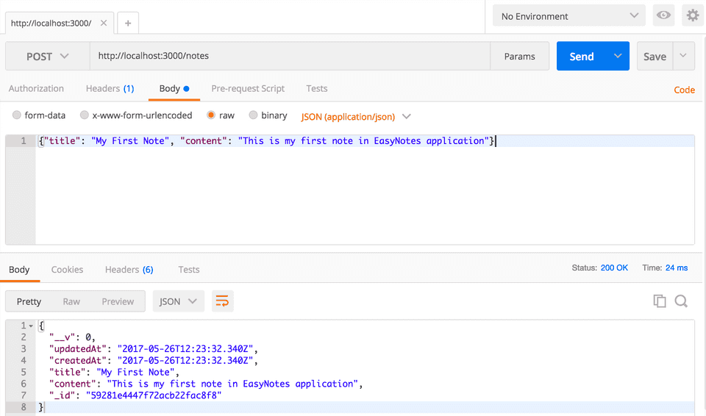](https://www.callicoder.com/static/78c19d5767482545362fec0f6a0da403/94cea/node-express-mongoose-rest-crud-api-create-a-note.png)

**Retrieving all Notes using GET /notes API**

[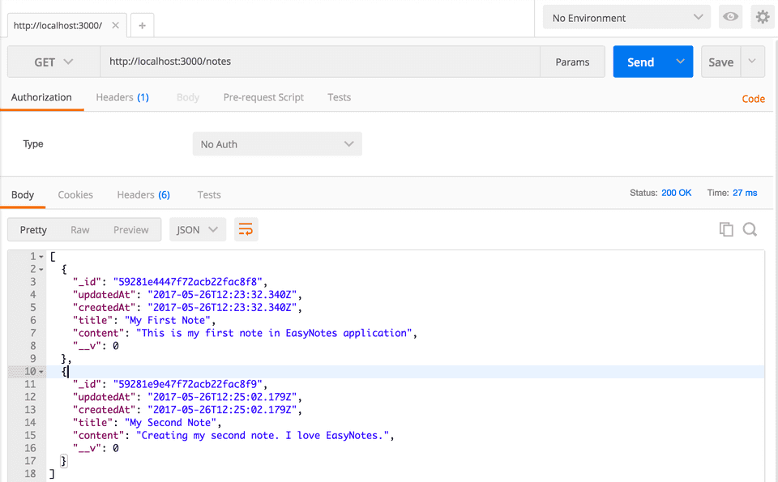](https://www.callicoder.com/static/2c49a3fa24d898897ab92542e2ec8f53/99e81/node-express-mongoose-rest-crud-api-retrieve-all-notes.png)

**Retrieving a single Note using GET /notes/:noteId API**

[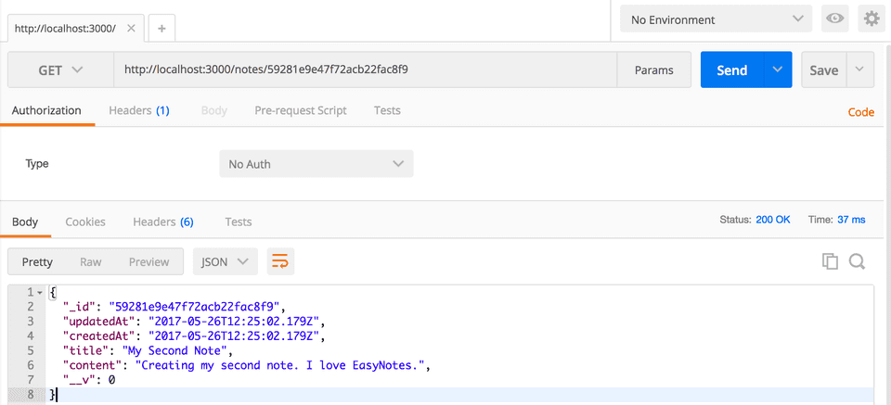](https://www.callicoder.com/static/4c267a898c82c3b04dac770946fc1723/6e52c/node-express-mongoose-rest-crud-api-retrieve-a-single-note.png)

**Updating a Note using PUT /notes/:noteId API**

[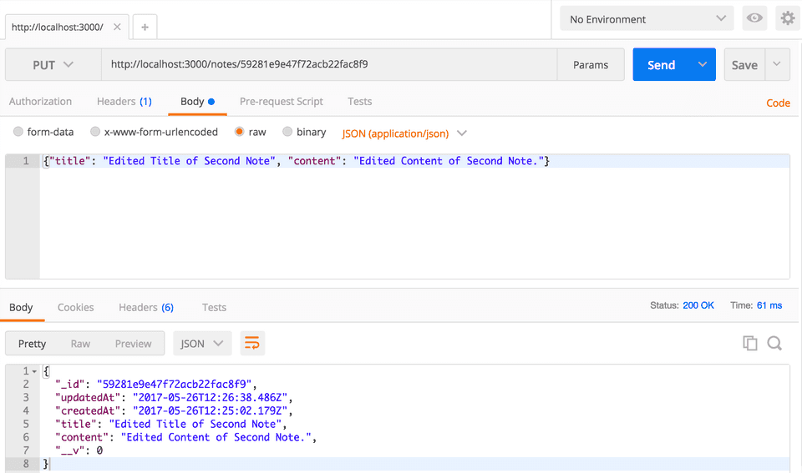](https://www.callicoder.com/static/847dc75187c01d45b6e0c093cf2b1c9c/cb1ac/node-express-mongoose-rest-crud-api-update-a-note.png)

**Deleting a Note using DELETE /notes/:noteId API**

[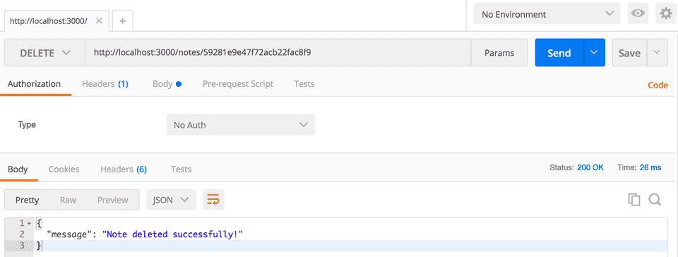](https://www.callicoder.com/static/a21c4b4a86f1043abb5969089c395f7e/cb1ac/node-express-mongoose-rest-crud-api-delete-a-note.png)